Basin: Vipava River Basin
Author(s): Manca Magjar, Aleksandra Krivograd Klemenčič, IzVRS
Date/version: 6nd of March 2015, v2, amendments 17th of April 2015, 20th of April 2015, 23rd of April 2015
- Narrative
  - Description of the basin
The Vipava RB is located in south-west Slovenia and is part of the Soča RB. The Vipava RB covers an area of 589 km² with a population of approximately 52,000 inhabitants. Geographically Vipava RB covers the entire Vipava Valley, part of Karst region (north-eastern part with Raša River) and Trnovo Forest (Trnovski gozd), Nanos Plateau and Hrušica Plateau (south-western part with Bela River). Vipava RB extends over a territory of 11 municipalities (Divača, Sežana, Idrija, Postojna, Vipava, Ajdovščina, Municipality of Nova Gorica, Komen, Miren - Kostanjevica, Rence - Vogrsko and Šempeter – Vrtojba) with a total of 172 settlements.
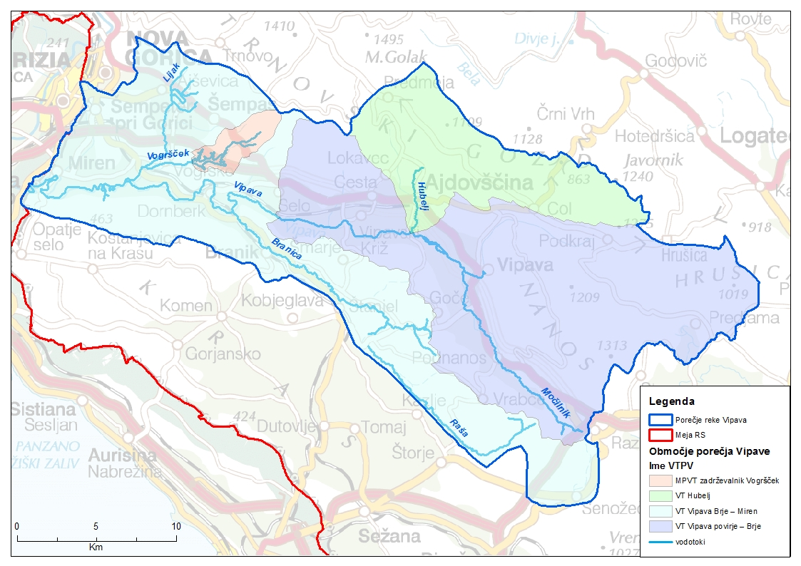
Figure 1: Vipava RB and its surface water bodies (IzVRS, August 2014)
Due to the location of the valley, the Vipava RB is subject to a strong Mediterranean climate interplaying with continental climate conditions. Average annual precipitations in the upper part of the Vipava Valley are around 2,000 mm per year, and in the lower part of the valley and the Vipava Hills around 1,500 mm per year. Maximum evaporation is in the southern part of the valley and decreases with altitude.
There are two prominent wind systems in the region (1) bora (NE wind) and (2) sirocco (S wind from the Sahara). The bora, which is integral feature of the Vipava Valley, can be present throughout the year but it is usually most common and the strongest in winter period with the average of 42 days per year. Settlements, where the bora frequently occurs, are built densely with narrow streets to reduce the impact of the bora. Buildings have stones on their roofs to prevent the tiles from being blown off. Slovenian cities where the strongest bora occurs are Ajdovščina, Vipava and, to a lesser extent, Nova Gorica. In Slovenia, the most affected section is usually the upper part of the Vipava Valley, stretching from Ajdovščina to Podnanos, where the speed of the wind gusts can exceed 200 km/h and thus causes damage to agricultural plants, buildings and causes problems in the traffic (restrictions for trucks and even cars).
The main water body in Vipava RB is the Vipava River, which is 47 km long with an average annual flow of 17.3 m³/s. The water level of the Vipava River is subject to big oscillations in flow due to torrential surface tributaries (e.g. Lijak and Hubelj). The Vipava Valley represents one of the most anthropogenically influenced areas in Slovenia with high level of alien fish species in river bodies, yet the Vipava river still represents a shelter for endangered autochthonous fish species unique to this area. This is one of the reasons most of the Vipava River as well as a large part of Vipava Valley is included in Natura 2000.
During heavy rainfall, landslides occur and threatens among others drinking water supply (power cuts, nonfunctional water pumps and water treatment) in some of the supply systems in Vipava RB.
During the period of regulation and canalization (1983-1986), a large area was ameliorated for agriculture, profoundly changing the water regime in the whole valley. The amelioration works performed in the 1980's included the construction of the largest Slovenian water reservoir with a high earth dam. Vogršček is a multi-purpose reservoir, primarily dedicated to providing irrigation for agricultural land and flood protection and, together with its associated infrastructure, represents the largest irrigation system in the country.
Agriculture, mostly production of fruit and wine, has always been of great importance in Vipava Valley due to the favorable climate conditions (vegetation season 2 months longer than in central Slovenia). 31% of land use in Vipava RB is for agriculture, mostly in the flatland around the Vipava River and its tributaries, while 63% of Vipava RB is covered with forest, mostly on the hinterlands and shady slopes of the Vipava Valley, the upper part of the basin and north and south periphery of the lower part of the basin. Abandonment of agricultural activity is an ongoing phenomenon in the basin.
Besides agriculture, industry is also an important sector in the region. Industry is present in all major cities of the Vipava Valley (e.g. Ajdovščina, Vipava, Šempeter pri Gorici, Nova Gorica), although it is more condensed in the lower part of the basin. In Ajdovščina, there are two important food processing factories: Fructal producing juice from the fruit grown in the valley; Mlinotest producing flour products with focus on pasta; and one of the biggest Slovenian textile factory Textina. Important industrial sectors in the valley are also electronics, construction industry and transport services. The number of new established micro, small and medium enterprises is increasing as people are developing new income opportunities, related to the abandonment of agricultural activities.
Municipality wastewater treatment in the basin is not sufficient which is reflected in poorer water quality in river bodies. Buildings in most of the smaller settlements still have (permeable) septic tanks instead of sewerage system or small wastewater treatment plants. There are two central wastewater treatment plants (WWTP) planning to be constructed in the near future in the basin for total 56,500 population units: (1) WWTP Vipava in the upper part of the basin and (2) WWTP Nova Gorica in the lower part of the basin with construction of sewerage systems of total length of 25,639 km.
With its rich natural and cultural heritage, the Vipava Valley especially in the upper part has a great potential for the development of tourism focusing on ecotourism. Besides surroundings in the lower part of the basin, Vipava wine road is a good starting point for countryside ecotourism.

  - Global change
Weather conditions in the basin show great year-on-year variability and significant climate variability in recent decades, which is even more pronounced in the last few years due to climate changes. Short but intensive rainfall results in flash floods at river basin and sub-basin scales. All this is increasingly coming to the fore in the last few years also as a consequence of climate changes.
In Slovenia, temperature measurements clearly show that the climate is heating up (ARSO, 2015). In the period 1951-2000 air temperature increased by 1.1 °C, and in the last 30 years, the heating exceeded the limit of 1.5 °C. (Kajfež Bogataj, 2006).
Climate change could accelerate the hydrological cycle, which indirectly affects the precipitation, evapotranspiration, size and timing of surface water runoff and the intensity of floods and droughts. Analysis of water balance in Slovenia for the period 1971–2000 (MOP-ARSO, 2008) show changes of the precipitation regime in the last years, with the increasingly pronounced autumn peak of percipations and deacreased amount of precipitation in other seasons. Evaporation is also changing with pronounced increase in comparison with period 1961-1990 (MOP-ARSO, 2008). As the consequence water flow regimes are changing with diminishing differences of water flow regime of rivers on a regional level. Water flow trends are generally declining. The comparison of the elements of the water balance in the 1971–2000 period with that in the 1961–1990 period (MOP-ARSO, 2008) also indicate an increase in evaporation and a reduction in the surface water runoff. In the short-term, above listed climate changes on a regional level have not yet caused water shortages, though locally they are increasing the risks to the provision of water.
Climate change projections for Slovenia publised at the Slovenian Environment Agency shows that the average annual temperature in the Vipava Valley will increase by 1.3°C or more by 2030 together with reduction of precipitation in the summer and increase in the winter. According to recent findings (Globevnik et al, 2013) climate change projections indicate reduction in annual surface water runoff in Slovenia for the period 2021-2050 by half compared to the average 1960 -1990 due to changes in temperature and precipitation. Expected reduction in annual surface runoff will lower water level (surface and groundwater) and consequently also increase water deficit in soil. More frequent and increased hydrological drought are expected, thus increasing water deficits in soil and decreasing underground water supplies. The fact is that over the past 40 years, Slovenia experienced many droughts, most of which occurred in the last 15 years. The most vulnerable regions are the coastal and north-eastern areas where total annual rainfall has been the lowest.
More detailed studies of the Vipava Valley regarding impact of climate changes were made for agricultural sector (Habjan, 2008). With some limitations it is assumed that, with increased average air temperature all over the Vipava Valley, water deficits in the soil will increase. Larger deficits are expected in soils that have poor water retention capacity. Together with the decrease of average precipitation during warmer part of the year (especially in summer months), an increase of various risks associated with agricultural production (e.g. crop failures and loss of income associated with either drought conditions or excess rainfall, increase of water demand due to increase in temperature that can lead to greater evaporative demand and thus water stress on crops) can be expected in the next decades.
Hydro-meteorological research shows that minor changes in the spatial and temporal distribution of precipitation in Slovenia can cause heavy regional problems, such as floods, droughts and water scarcity that can lead to socio-economic losses and have a significant impact on the environment.

Source:
MOP-ARSO, 2008. Frantar P. (Editor), Bat M. et al (Authors), Water balance of Slovenia 1971–2000, Ministry for Environment and Spatial Planning – Environmental Agency of the Republic of Slovenia, 2008; webpage: http://www.arso.gov.si/vode/poro%C4%8Dila%20in%20publikacije/vodna%20bilanca/vodna_bilanca.html, April 2015.
Globevnik L., Kurnik B., Verdnik N., Snoj L., Šubelj G., 2013: Article in the proceedings called »24. Mišičev vodarski dan 2013« published on website: http://mvd20.com/LETO2013/R15.pdf, April 2015.
Habjan M., 2008: The analysis of water balance in the Vipava valley, Graduation Thesis, webpage: http://www.digitalna-knjiznica.bf.uni-lj.si/dn_habjan_miha.pdf, April 2015.
ARSO, 2015: Slovenian Environmental Agency, webpage: http://www.arso.gov.si/podnebne%20spremembe/projekti/arso_klimatske.html, April 2015.
Kajfež Bogataj L. 2006. Climate change and the future of Slovenia. Discussions on the future of Slovenia. 9th Discussion. The challenges of climate change. Office of the President of the Republic of Slovenia, Ljubljana, 62-69 pp. (in Slovene); webpage: http://www.prihodnost-slovenije.si/up-rs/ps.nsf/krf/61945F3137873F3AC12570BD002FB45A?OpenDocument, April 2015.

  - Challenges
Stakeholders identified three major challenges in the Vipava River Basin (a) Water availability during droughts in growing season, (b) Flood risk reduction, (c) Appropriate water quality.

    - Challenge 1: Water availability during droughts in growing season
Main challenge indicated by stakeholders is water availability during drought occurences, especially in growing season. In Vipava RB meteorological, agrometeorological and hydrological droughts are present, each having a specific impact on the environment.
When droughts occur, there can be a problem of water availability for a variety of activities, sectors (water users) and for the ecosystems. Water availability during droughts in growing season is most important for agriculture. The main cause of the drought occurence in agriculture is lack of available water for both rainfed and irrigated crops. The main problems why water is unavailable during droughts in growing season are listed bellow.
- In the past droughts were always present in Vipava RB, but in the last few years they are occuring more frequent and at a larger scale. Beside climate changes, one of the reason are changes in the river regime caused by regulations of watercourses (Vipava, Hubelj, Lijak) in 1980s and earlier, and amelioration works to drain excessive water from soil. The consequences are more rapid surface water runoff from the basin, increased flow velocity, decreased retention function of the riverbed and soil and reduced water infiltration causing lowering groundwater level. As a result of all above listed, the water cycle in the basin is also changed.
- Although several water reservoirs and irrigation systems were planned to be constructed in Vipava Valley (e.g. Branica, Pasji rep, Močilnik, Malenšček-Kamenski potok, Vrtovinšček, Lokavšček, Košivec) in 70's (Republic Green plan, 1970-1980) only water reservoir Vogršček with corresponding irrigation systems for lower part of the valey were actually constructed. The reasons were changed priorities of the Republic of Slovenia and thus available funds at that time were transferred into construction of highways. After that, several plans of different water reservoirs were discussed, but not yet realized.
- Water reservoir Vogršček represents a major intervention in the valley’s water cycle, yet with undesirable results, attracting political and professional criticism for many years. The main problem is unclarified ownership of the reservoir and its infrastructure between government and the private sector, which, in the past 20 years, has resulted in poor management, improper functioning, lack of operation and maintenance funding. Total designed volume (both lower and upper reservoir) of Vogršček is 8.5 million m³ of water. Vogršček has been designed to provide water for the irrigation of the lower Vipava Valley, amounting 84.5% of the total useful volume (6.8 million m³). Although planned (Republic Green plan, 1970-1980) all the corresponding irrigation systems were not constructed. Today’s capacity of Vogršček is only 1.8 million m³ water per year, which mean possible irrigation of 1,400 ha of agricultural land. Due to sub-optimal functioning of the Vogršček (leakage of the barrier, low water level resulting in low pressure for optimal irrigation) only approximately 1.3 million m³ of water per year (1,000 ha of agricultural land) is used for irrigation. There are also illegal connections to irrigation system which are additionaly worsening the functioning of the system, and making water less available for those users who are paying for water used. There are many challenges that need attention in Vogršček (a) better understanding of the system functioning, (b) more transparent functioning of the system (with no illegal connections); (c) cooperation between the users (16 irrigation communities), (d) organization of optimal irrigation (irrigation time plan) and (e) technological renovation and modernization of the reservoir and connected irrigation systems.
- The Vipava River, as the only water source for irrigation in upper Vipava RB, features a rainfall regime (flow is directly dependent on the percipitation regime in the catchment area). In dry periods when water is needed for agriculture irrigation, there are restrictions for water abstraction from the river due to maintenance of the ecological flow (WFD). Nevertheless, illegal water abstractions from Vipava River exists also during low flows thus exacerbating the negative impacts of drought on aquatic, riparian and wetland ecosystems (reduced water flow, flow cessation, eventually complete desiccation; resulting in not achieving good ecological status of surface waters according to WFD). Already, some experts claim that the irrigation needs in the Vipava Valley are greater than the available water quantities and other water sources beside water reservoir Vogršček would be needed.

When droughts occur, they can cause damages to water distribution systems infrastructure – damaged, broken water pipes, causing unavailability of drinking water on some areas of Vipava RB.
In the frame of Republic Green plan (1970-1980), wind barriers were planted (trees like black alder (Alnus glutinosa) or hornbeam (Carpinus betulus), with the combination of shrubs like hawthorn (Crataegus sp.) or blackthorn (Prunus spinosa)) to minimize the impact of bora wind on agriculture. Due to illegal removal of already planted wind barriers by farmers (lack of awerness) and improper agricultural practice, deflationary effects of bora wind, especially in winter is even stronger.
Source:
Stakeholder workshop Vipava River Basin, 10th of June 2014, sessions Challenges and issues (annex image 1, 4). Interviews, October 2014, interviewee no. 1, 7, 8, 9, 11, 14, 16).
FCM validation with stakeholders, February 2015.

    - Challenge 2: Flood risk reduction
Floods were always present in Vipava RB and represent a bigger problem in the lower part of the RB, but due to the climate change, changes of river regime due to regulations of the watercourses in 1980s and building settlements too close to the watercourses (deprivation of riparian area) severe floods are occuring more frequently and at a larger scale. Due to trapped and rigidly regulated watercourses (concrete banks) in the upper valley, which are lacking the needed space and the ability to reduce the flow velocity, water rapidly drains downstream causing severe floods in the lower valley.
One of the main challenges identified by stakeholders regarding flood risks management is lack of competences between local and national authorities mostly due to vague legislation. Most problematic are smaller watercourses not recorded in the water cadastre. Additionally, when talking about flood risks in Vipava RB, municipal spatial planning and its effect on flood occurrence needs to be mentioned. In Vipava RB there are 11 municipalities, but not all of them are influenced by floods. Each municipality is managing its own area without considering the impacts of their measures upstream or/and downstream of the watercourses and thus increasing flood risks outside their area.
Landslides which occur over the entire area of the Vipava Valley where the terrain is sloping have also impact on floods occurrence although indirectly. The biggest and most dangerous areas for landslides occurence are on the northern slope of the valley that descend from Trnovo Forest (Trnovski gozd) into the valley. The landslides and also many other slope-movement phenomena originate in the current geological structure of the valley and in the formation of the terrain. However, most landslides are triggered by heavy rainfall.
In Vipava RB due to unappropriate spatial planning urbanisation of the valley slopes increased the possibility of triggering landslides mostly due to inappropriate regulation of stormwater and hinterland water drainage. Also poor maintainance of drainage system built more than 30 (or 50) years ago like regulations of torrents and inadequate drainage of stormwaters, contribute to triggering landslides more often. Landsliding not only threats buildings and infrastructure, but also causes morphological changes of the terrain. Landslides often move large amounts of sediments, which not only stay on the slopes, but also reach the fluvial network. Under extreme weather conditions, land sliding may lead to torrential outbursts, debris flows or dam-break waves after a dam-breach of natural dams. As a result, floods of larger scope occur.
Source:
Stakeholder workshop Vipava River Basin, 10th of June 2014, sessions Challenges and issues (annex image 1, 2, 3, 4). Interviews, October 2014, interviewee no. 1, 7, 8, 9, 11, 14, 16).

    - Challenge 3: Appropriate water quality
The ecological status of the Vipava River is moderate due to organic pollution (agriculture, insufficient municipal wastewater treatment, regulation of watercourses).
One of the main reasons for unappropriate water quality in Vipava RB is insufficient municipal wastewater treatment. In order to solve the current situation and most importantly due to compliance with legislative requirements, two waste water treatment plants (WWTPs) are planned to be constructed in the near future. In the upper valley WWTP Vipava and in the lower valley WWTP Nova Gorica (in Vrtojba), which is already in the phase of construction. However, there is still unsolved problem of insufficient municipal wastewater treatment in small and dispersed settlements.
When Vipava River and its tributaries (Lijak, Hubelj, etc.) were regulated and canalized in 1980s in order to increase area of arable land, the length of the Vipava River was shortened from 50 to 47.7 kilometres mostly due to the elimination of meanders. Due to regulations, many habitats for aquatic and riparian plants and animals dissapear. The result is lower self-cleaning ability of watercourses resulting also in moderate ecological status.
When talking about the Vipava River and agriculture in Vipava RB, challenges of too excessive water abstraction need to be mentioned. Abstractions of water for irrigation purposes are the largest on the Vipava River. Also deficient supervision of water abstractions and problem of excessive number of concessionaires on the same watercourse is identified. Hence it could be a problem to maintain ecologicaly acceptable flows.
Monitoring of water quality in Vogršček reservoir confirmed presence of faecal coliforms (Tratnik, 2015). The source of contamination are most probably septic tanks overflows in the catchment area. Since water in Vogršček occasionnaly contains too many coliforms, the use of water for irrigation purposes is limited.
Another cause for sub-optimal functioning of the Vogršček is the improper connection of the irrigation system to the reservoir due to floor outlet, resulting in (a) exceptionally cold water unsuitable for irrigation, and (b) water full of sediments also unsuitable for irrigation (fruits like peaches and vegetables must be cleaned constantly) (Delo, 2013 and Kodrič, 2014).
A pre-condition for water ecotourism development like natural bathing sites on the Vipava River is appropriate bathing water quality. With bathing waters on Vipava River microbiologically inappropriate, desired ecotourism cannot develop.
Source:
Stakeholder workshop Vipava River Basin, 10th of June 2014, sessions Challenges and issues (annex image 1, 3, 4). Interview, October 2014, interviewee no. 1.
Kodrič I., 2014: Meeting with stakeholder in the context of collecting qualitative data, August 2014.
Tratnik M., 2015: FCM validation as individual consultation, 17th February 2015.
Delo, 2013: Article in newsletter Delo, 6th of September 2013, website: http://www.delo.si/novice/slovenija/ministrstvo-odlozilo-sanacijo-vogrscka.html, April 2015
http://www.arso.gov.si/varstvo%20okolja/poro%C4%8Dila/poro%C4%8Dila%20o%20stanju%20okolja%20v%20Sloveniji/zdravje.pdf, April 2015

  - Basin dynamics
A cognitive map of the basin is presented in Figure 2. The map reflects the interactions and dynamics in the basin based on the understanding by stakeholders. The map is centered around the three challenges described above and the cognitive map includes eighteen (18) factors connected with each other. Based on stakeholders comments, five main drivers of the system were identified (precipitation, industrial production, wind, water infrastructure and forest management, river basin management, and air temperature in growing season) that affect either directly the aforementioned challenges in the basin (water availability, flood damages and water quality) or indirectly through several (9) factors. The definitions and the interrelationships between the factors of the basin are presented in the Tables I1 & I2 of the Annex.

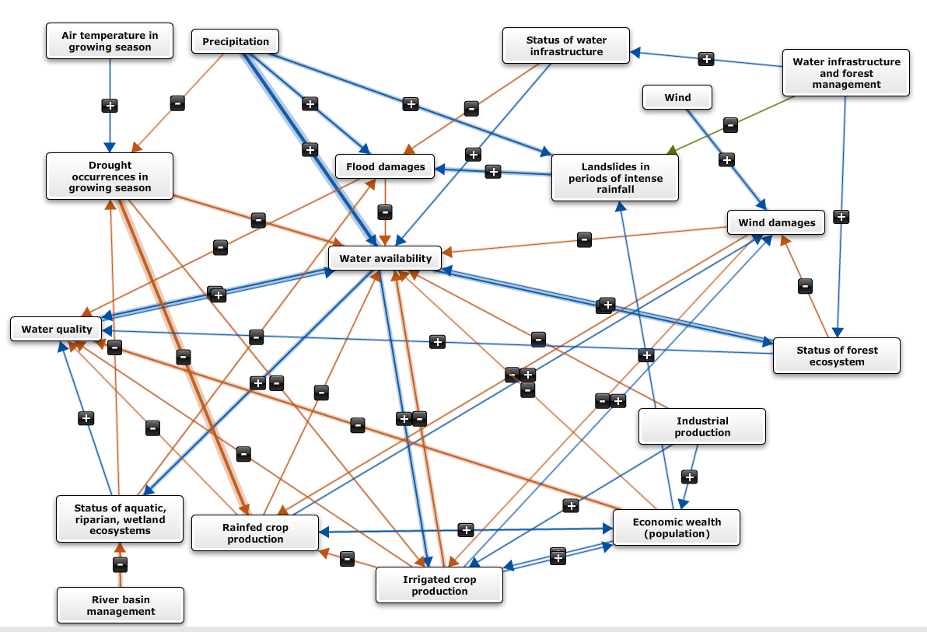
Figure 2: cognitive map of the Vipava river basin

Due to the interaction with numerous factors in the map, water availability is the main factor in the Vipava cognitive map and and its linkages to other factors are described here in more detail.

Water availability is positively affected by precipitation, water quality, status of water infrastructure and status of forest ecosystem. Precipitation has the strongest positive influence on water availability, because precipitation is the main source of water in the valley. Namely, precipitation on plateaus north and north-east side of the basin recharge numerous karst springs (Hubelj, Mrzlek) on the outskirts of plateaus that are intended for water supply. Water availability is positively (medium strenghth) influenced by water quality since more water of better quality means more water available for users (drinking water, water for irrigation and industry). Finally, the status of forest ecosystem positively affects water availability in the lower part of the basin, because the main catchment area of the Vipava river are plateaus in the north, north-east side covered with forest.
Water availability is most strongly negatively affected by drought occurences in growing season, and the intensity of rainfed and irrigared crop production. More droughts occurences result in less water being available in the basin. The strength of drought occurrences on water availability is medium as the main catchment area of the Vipava River is less vulnerable to the conditions in the flat part of the basin (from Vipava’s springs downstream). In the flat part of the basin, where agricultural land is present rainfed crop production prevails. More rainfed crop production means higher water uptake by plants and less water available for water-dependent ecosystems and sectors. With regards to irrigated crop production, water used for irrigation means irreversible water use and it therefore negatively affects water availability. Irrigated crop production is present mostly in the lower part of the basin, near water reservoir Vogršček and where irrigation systems are present and functioning. In the upper part of the basin, irrigation of agricultural land is also present and the Vipava River is the only water source for irrigation.
Water availability is affecting other factors in the basin. Water availability positively influences 1) aquatic, riparian, wetland and forest ecosystems and 2) water quality. Water availability positively affects irrigation crop production in Vipava RB and status of aquatic, riparian and wetland ecosystems. If more water is available in streams, soil and groundwater, basin ecosystems (aquatic, riparian, wetland and forest) are in better state. Furthermore, when there is more water in watercourses and groundwater, water quality is of better quality mostly due to dilution of (potential) pollutants. Finally, if more water is available in watercourses, which are the main water source for irrigation (Vipava River and Vogršček), irrigated crop production is higher. Medium strong relationship between water availability and irrigated crop production is determined as irrigation in the basin is not developed to its full capacity and other factors have bigger effect on irrigated crop production like the development and condition of irrigation systems.

Water quality beside water availability interacts with numerous factors (7). Water quality is affected negatively by economic wealth, including population and settlements development in the RB and agriculture (rainfed and irrigatied crop production). Due to small and dispearsed settlements in basin with insufficient drainage and municipal wastewater treatment, organic pollution is affecting negatively the water quality. Agriculture with the use of plant protection products and fertilizers is also one the sectors affecting negatively the water quality.

Last but not least are flood damages, related to the basin challenge Flood risk reduction. Precipitation positively affect flood damages because longer periods of rainfall or even shorter periods of heavy rainfal usually lead to flood events causing damages mostly to infrastructure and also trigger lanslides. When landslides trigger they move large amounts of sediments, which not only stay on slopes, but also reach the fluvial network. Under this conditions, land sliding may lead to torrential outbursts, debris flows or dam-break waves after a dam-breach of natural dams. As a result, floods of larger scope occur.

Negatively, flood damages equally strong affect water availability and water quality. Namely, floods cause damages to water supply systems and turbidity of water at the source. Due to inactivity of pumps and water treatment, less drinking water of proper quality is available for its users.

Annex
Table I.1: documentation of the factors in the cognitive maps
Please describe the factors that have been included in the final map, as well as their definition. Feel free to add any comment you consider relevant.
Restrict the number of factors to not more than about 20 factors

Number | Name of factor | Definition | Comment
f1 | Precipitation | Annual average precipitation. | Changes in precipitation regime.
f2 | Air temperature in growing season | Growing season - the period of time in a given year when the climate is prime for both indigenous and cultivated plants experience the most growth. | Growing season depends on the type of indigenous vegetation and cultivated crops (e.g. for peaches and nectarines from March to October).
f3 | Wind | Strong bora wind, cold and gusty northeastern wind, especially in the cold half of the year (October to March). | Very important climate factor.
f4 | Water infrastructure and forest management | Management of water infrastructure of aquatic and riparian area, forests. | Government through different Ministries manages water infrastructures and forests. Water infrastructure – e.g. dams, check dam
f5 | Drought occurrences in growing season | Droughts that occur in growing season. Meaning meteorological and hydrological droughts.
f6 | Flood damages | Damages caused by floods along the Vipava river and its tributaries. | Damages caused to infrastructure (roads, buildings), agriculture.
f7 | Landslides in periods of intense rainfall | Landslides on the slope of the Vipava valley – mostly associated with geological and morphological conditions. | Most important landslides occur on the northern slopes that descend from Trnovo forest into the valley.
f8 | Wind damages | Damages caused by strong bora wind. | Damages caused to infrastructure (electrical network, buildings), argiculture and traffic.
f9 | Status of water infrastructure | Physical condition of existing water infrastructure – e.g. accumulation with dam (Vogršček), river embankments, check dams (storage of sediments) | Definition in 44. Article of Waters Act; also facility for water monitoring.
f10 | Status of forest ecosystems | Ecological condition of forest ecosystems. | About 60 % of the RB Surface is covered with forest. The catchment area of Vipava river is the slopes of Nanos and Hrušica – hinterland covered mostly by forest.
f11 | Status of aquatic, riparian, wetland ecosystems | Ecological, Hydrological, Morphological, Biological status of aquatic, riparian and wetland ecosystems | Ecological status of aquatic ecosystems; ecological features of the ecosystems; morphological – structure and function of habitats for organisms; hydrological status of habitats – water velocity, water depth, etc.  biological features – e.g. species composition
f12 | Water availability | The availability of the water at its source (river, spring, accumulation) for all users – ecosystems and needs arising from human activities. | Availability also depends on the capacity of the facility installed to withdraw the water from the water source.
f13 | Water quality | Physico-chemical parameters of water. | Parameters of the chemical and ecological status of surface water and groundwater chemical status.
f14 | River basin management | Management of surface waters and groundwater; e.g. the status, programe of measures, maintenance and investment work planned and carried by concessionare with confirmation of ministry responsible for the environment. | Including construction works, which have been and are still being carried on watercourses and not as RBM as we know it (meaning sustainable measures).
f15 | Rainfed crop production | Crops that are not irrigated and they are dependent only from rain.
f16 | Irrigated crop production | Crops that are irrigated (also in closed spaces – glasshouses). | Most common: peaches, vegetables.
f17 | Economic wealth (population) | Including population and settlements development in the RB. | Consumption (of water) or other environmental issues are conditioned by status of economic wealth or population well-being (urban water use, water pollution - urban waste waters, (un)regulated building of new settlements).
f18 | Industrial production | Mostly food processing and textile industry. | Food processing industry – bevarage production (Agroind Vipava 1894, Fructal, Mlinotest), textile industry (Tekstina), also wood and construction industry.

Table I.2: documentation of the relationships in the cognitive maps

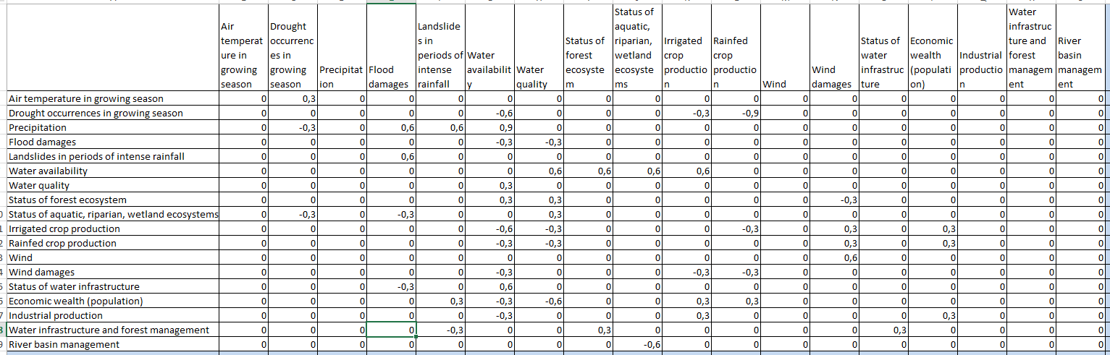

Table I.3: documentation of the reasoning behind the relationships in the cognitive maps
- Please justify (to the extent possible) the reason for defining the type of relationships that were drawn.
- The table should contain at least one row for each relationship (arrow) that you included in your map. You may include more rows if you wish to explain why a certain relationship has not been included in your map
- The codes f1, f2,…,f20 should refer to the factors described in Table I.1

From | To | Justification | Comment (strenght of the relationship)
f1 | f5 | more precipitation mean less drought occurences | 1-: weak negative relationship
f1 | f6 | longer periods of rainfall or even shorter periods of heavy rainfal cause flood events that cause damages mostly to infrastructure | 2+: medium positive relationship
f1 | f7 | longer periods of rainfall or even shorter periods of heavy rainfal can trigger landslides; in Vipava RB it has been observed that most lanslides are triggered in periods of heavy rainfall, due to impacts of water on the geological structure and formation of the terrain | 2+: medium positive relationship
f1 | f12 | more precipitation mean more water available in streams, soil and groundwater; for ecosystems (aquatic, riparian, wetland and forest) and water users (agriculture, households, industry) | 3+: strong positive relationship
f2 | f5 | if air temperature (average annual or monthly) in growing season is getting higher, more droughts occur (weak relationship as droughts are not affected just by the air temperature, there are other factors like changes in precipitation patterns – temporal, spatial) | 1+: weak positive relationship
f3 | f8 | strong Bora wind (mostly from October to March) cause wind damages, mostly to infrastructure and vegetation | 2+: medium positive relationship
f4 | f7 | current management of water infrastructure is present in the basin, but is not efficient enough, so weak positive relationship is defined as more landslides occur due to not optimal drainage and maitainance of exsisting water infrastructure | 1-: weak negative relationship
f4 | f9 | current management of water infrastructure is present in the basin, but is not efficient enough, so weak positive relationship is defined as status of water infrastructure is not optimal; only important (most needed) intervention works are done and less maintenance works are carried out | 1+: weak positive relationship; example for water reservoir Vogršček – leakage on the dam - intervention works were carried out but due to lack of funding only 1st phase was carried out; water infrastructure on torrents are in poor state not serving its purpose, etc.
f4 | f10 | forest management is present in the basin and is positively affecting status of forest ecosystem, as most of the forest is in the hinterlands of the basin (sparsely populated) and only present in small parts of the valley where established protected areas of forest along Vipava river; weak positive relationship was determined | 1+: weak positive relationship; (Forest management service - units Tolmin and Ajdovščina)
f5 | f12 | when droughts occur in growing season there is less water available for ecosystems and their services and for water users (agriculture sector, urban users) | 2-: medium negative relationship
f5 | f15 | increased frequency and intensity of droughts in growing season (mostly crop-growing periods) reduces the rainfed crop production (smaller or loss of income) - droughts can harm crops and reduce yields, water demand of crops is difficult to meet as water supplies are reduced | 3-: strong negative relationship; SH in 1st WS indicated, that droughts pose a bigger problem for agriculture in the upper part of the RB. In the period from April to September major part of the Vipava valley is endangered or very endangered by drought.  (http://geo.ff.uni-lj.si/pisnadela/pdfs/zaksem_201407_jus_znidarsic.pdf).
f5 | f16 | increased frequency and intensity of droughts in growing season (mostly crop-growing periods) reduces the irrigated crop production (smaller or loss of income) - droughts can harm crops and reduce yields, water demand of crops is difficult to meet as water supplies are reduced | 1-: weak negative relationship; only a small part of the agricultural land is being irrigated from water reservoir Vogršček (lower part of the basin) and Vipava river (upper part of the basin) (irrigation needs in the Vipava Valley are greater than the available water quantities and other water sources beside water reservoir Vogršček would be needed)
f6 | f12 | floods cause damages to water supply systems (power failure – problems in water purifying plants, after heavy rainfall water in karst spring becomes turbid and it needs to be cleaned for further use) and so less water is available for its users | 1-: weak negative relationship
f6 | f13 | floods cause damages to water supply systems (power failure – problems in water purifying plants, after heavy rainfall water in karst spring becomes turbid and it need to be cleaned for further use) and so quality of drinking water deteriorates, also surface water becomes turbid, carring potential pollutants downstream – surface water quality also deteriorates | 1-: weak negative relationship
f7 | f6 | more landslides trigger in periods of intense rainfall, more damages caused by floods occur; when landslides trigger they move large amounts of sediments, which not only stay on slopes, but also reach the fluvial network. Under catastrophic conditions, land sliding may lead to torrential outbursts, debris flows or dam-break waves after a dam-breach of natural dams. As a result, floods of larger scope occur. | 2+: medium positive relationship; lanslides occur on specific places of the basin, where the terrain is becomming more steep (hillslopes)
f8 | f12 | strong bora wind damages infrastructue and causes power failure - drinking water cannot be transported to some settlements, also purifiying plant for drinking water cannot not work | 1-: weak negative relationship, temporally and spatially limited impact
f8 | f15 | strong bora wind causes damages in agriculture mostly through wind erosion - removal of top soil, additionaly drying soil and causing damages to the crops (damages to leaves); the result is lower crop production | 1-: weak negative relationship, spatially limited impact meaning where planted wind barriers, this effects are not so strong, and where strong bora wind prevails, permanent grassland are present
f8 | f16 | strong bora wind causes damages in agriculture mostly through wind erosion - removal of top soil, additionaly drying soil and causing damages to the crops (damages to leaves); the result is lower crop production | 1-: weak negative relationship, spatially limited impact, where irrigation prevails, wind is not so strong and causes less damages; the expansion of irrigation crop production in greenhouses is also limited
f9 | f6 | if status of infrastructure is good, floods cause less damage | 1-: weak negative relationship; spatially limited impact, e.g. water reservoir Vogršček also provides flood safety downstream, but due to leakage of the dam and not finished intervention works, lower water level is maintained by higer discharge of water into Vogršček
f9 | f12 | if status of water infrastructure, where present and intended for water use (eg. irrigation system) is in good condition, working properly, more water is available for ecosystems and sectors (agriculture) | 1+: weak positive relationship; spatially limited impact, some wáter infrastructure is present but not in good condition to fully provide water available in the basin
f10 | f8 | when forest is in good condition, there are less damages caused by strong bora wind | 1-: weak negative relationship; weak relationship is due to low percent of forest in the form of wind barriers (wind breaks) in the valley
f10 | f12 | the main catchment area of the Vipava river and its tributaries are plateaus in the north, north-east side covered with forest, the status of forest ecosystem positively affects water availability in the flat part of the basin | 1+: weak positive relationship
f10 | f13 | if the forest ecosystems is in better status, water is better quality - forests impact positively on quality of surface and ground water through minimizing soil erosion on site, thus reducing sediment in water bodies (wetlands, ponds and lakes, streams and rivers), and through trapping or filtering other water pollutants | 1+: weak positive relationship; in the hinterland of the basin forests prevail, this area is also sparsely populated;  good chemical status of groundwater and moderate status of surface waters
f11 | f5 | with better status of aquatic, riparian, wetland ecosystems more water is retained and not drained away (better retention function, inflitration of water in the ground) and so less hydrological drought occur | 2-: medium negative relationship
f11 | f6 | with better status of aquatic, riparian, wetland ecosystems flood cause less damages, ecosystems services slow down the flow velocity – like for example menders and floodplains connected to the river | 1-: weak negative relationship; some floodplains and meanders are present in the lower part of the basin, and are in a function of slowing down the flow velocity, but due to cannot alone reduce the extend of floods due to regulations of the watercourses in the upper part on the basin (more rapid water runoff from the basin, increased flow velocity, decreased retention function of the riverbed and soil)
f11 | f13 | with better status of aquatic, riparian, wetland ecosystems better self-cleansing capability of the aquatic environment (improvement in water quality through reduced nutrients) | 1+: weak positive relationship; weak relationship due to moderate ecological status of surface water
f12 | f10 | water available in streams, soil and groundwater, satisfyies basic environmental needs and if more water is available, forest ecosystem is in better state | 2+: medium positive relationship
f12 | f11 | water available in streams, soil and groundwater, satisfyies basic environmental needs and if more water is available, aquatic, riparian, wetland ecosystems are in better state | 2+: medium positive relationship
f12 | f13 | when there is more water in watercourses and groundwater, water quality is of better quality mostly due to dilution of (potential) pollutants | 2+: medium positive relationship; in the case of where net water quantities increase by moderate amounts, and surface water quality will generally improve as streams fill and dilute their pollutants
f12 | f16 | when more water is available for irrigation, agriculture production is higher | 2+: medium positive relationship; spatialy limited impact
f13 | f12 | if water is of better quality, more water is available for users (drinking water, water for irrigation and industry) | 1+: weak positive relationship; one of the factor, but not the most important one - for domestic use raw water is being purified (due to nature of Hubelj (and Mrzlek) karst spring, used for drinking water, water is being purified with the help of water purification plant)
f14 | f11 | due to past regulations of watercourses and also due to unproper intervention works on watercourses, aquatic, riparian and wetland ecosystems are not achieving e.g. good status according to Water framework Directive and natural habitats and habitats of species according to Habitats Directive | 2-: medium negative relationship
f15 | f8 | if rainfed crop production is expanded or intensified, more wind damages occur due to expansion of arable land – in the past farmers alone have removed wind barriers that were introduced with Republic Green plan to expand the arable land – consequently more wind damages occur | 1+: weak positive relationship
f15 | f12 | if rainfed crop production is expanded or intensified, the higher water uptake by plants and less water available for water-dependent ecosystems and sectors | 2-: medium negative relationship
f15 | f13 | if rainfed crop production is expanded or intensified, water quality deteriorates due to the use of plant protection products and nutrients | 1-: weak negative relationship; less pollution than from settlements (nutrients), but still present in Vipava RB, fungicides in fruit growing, Viticulture
f15 | f17 | if rainfed crop production is expanded or intensified, economic wealth gets higher – jobs guaranteed with higher income | 1+: weak positive relationship
f16 | f8 | if irrigated crop production is expanded or intensified, more wind damages occur due to expansion of arable land – in the past farmers alone have removed wind barriers that were introduced with Republic Green plan to expand the arable land – consequently more wind damages occur | 1+: weak positive relationship; limitations for vegetable crop production in closed areas (greenhouses) as wind tends to damage infratsructure
f16 | f12 | if irrigated crop production is expanded or intensified, less water is available for water-dependent ecosystems and sectors | 2-: medium negative relationship; Water is used for irrigation that means irreversible water use. Irrigation crop production is present mostly in the lower part of the basin, near water reservoir Vogršček and where irrigation systems are present and functioning. In the upper part of the basin, irrigation of agricultural land is also present and the Vipava River is the only water source for irrigation
f16 | f13 | if irrigated crop production is expanded or intensified, water quality deteriorates due to the increased use of plant protection products and fertilizers | 1-: weak negative relationship; less pollution than from settlements (nutrients), but still present in Vipava RB, fungicides in fruit growing, vegetable crop production
f16 | f15 | if irrigated crop production is expanded or intensified, area intended for rainfed crop production decreases – only if no expansion of arable land is planned | 1-: weak negative relationship
f16 | f17 | if irrigated crop production is expanded or intensified, economic wealth increases – jobs guaranteed, self-sufficiency increases | 1+: weak positive relationship; due to low purchase prices, agriculture crop productions is not so strong(e.g. peaches)
f17 | f7 | with increased economic wealth the expansion of settlement (individual houses) also occur and if the buildings extend into “problematic”terrain more lanslides in periods of intense rainfall can occur due to inadequate regulation of stormwater and hinterland water drainage | 1+: weak positive relationship; spatialy limited impact – on the slopes
f17 | f12 | if economic wealth gets higher and the population increases, domestic water use decreases water availability | 1-: weak negative relationship; less water is used compared to the past, some SH say that due to the economic crisis people care more about the consumption
f17 | f13 | if economic wealth and the population increases, water quality deteriorates (more waste, waste waters) – in basin small and dispearsed settlements have insufficient drainage and municipal wastewater treatment that are causing organic pollution of the surface water | 2-: medium negative relationship
f17 | f15 | if economic wealth and population growth increases, rainfed crop production can be expanded or intensified due to increase in demand for food | 1+: weak positive relationship
f17 | f16 | if economic wealth and population growth increases, irrigated crop production can be expanded or intensified due to increase in demand for food | 1+: weak positive relationship
f18 | f12 | if the industrial production increases (heavy industry), water availability decreases – industry using a great amount of water (Fructal, Mlinotest, Tekstina) impacts water availability (where the same water source is being used - Vipava river, Hubelj spring) | 1-: weak negative relationship; only if industry increases the consumption of water
f18 | f16 | if the industrial production increases (food procesing industry, bevarage production), irrigated crop production is expanded or intensified due to the increase in demand for crops | 1+: weak positive relationship; industrial activities, food processing, beverage production purchase crops – right now as food processing industry is not so strong, low purcase prices for peaches allow only a small portion of irrigated crop production
f18 | f17 | if the industrial production increases, economic wealth together with population growth increases | 1+: weak positive relationship; industrial activities (SME) are not so strong but still people work there and so the industry enables population development and economic wealth

