**INTRODUCTION AND BACKGROUND**

The COVID-19 pandemic and consequent restricted movement of people has made it extremely difficult for Centres of Excellence (CoEs) and UNESCO to pilot courses using conventional modalities of face-to-face, classroom lectures, lab sessions and field work. The ACEWATER II project, therefore, aims to provide support to CoEs for alternative course delivery such as digitalisation of course materials, distance and on-line learning. It is likely, following this current emergency, that these modalities will become more mainstream and much more the norm compared to how we currently implement such activities.

The **purpose of this study** was to evaluate the current level of capacity of CoEs to implement online e-learning courses for professional and technician levels during the remainder of the project. The study targeted existing staff and institutional capabilities to deliver online e-learning as well as access to hardware, software and technical support for its delivery. The results of this study will be accompanied by supporting documents of course outlines, budget breakdowns and work plan; to be followed up by Network Secretariats and UNESCO Coordination.

This report is structured within **five distinct sections** namely Background; Institutional Online E-Learning Experience; Staff Online E-Learning Experience; Institutional Level Technical and Learning Support; and Student (capacity) Online E-Learning Experience. Within each section the data and analysis are presented at two levels, but also integrated. Firstly, at regional level (SANWATCE, WANWATCE and CEANWATCE) (Figures 1-14) and secondly at inter-CoE level (Tables 1-5). It should be noted that SANWATCE provided eleven responses, WANWATCE and CEANWATCE, four responses each. At these two levels of analysis, this report highlights major differences, similarities, trends and anomalies.

It should be noted that not all results are representative of the entire CoE, department/faculty or institution, and vice versa. In other words, some indicators and sections looked at individual/respondent level, while others investigated at CoE or department/faculty level.

**LIST OF NEPAD WATER CENTRES OF EXCELLENCE**

**SANWATCE**

Water Centre – Council for Scientific and Industrial Research (CSIR) (South Africa)

Department of Environmental Science – University of Botswana (UB) (Botswana)

International Center for Water Economics and Governance in Africa (IWEGA) – Universidade Eduardo Mondlane (UEM) (Mozambique)

Centre for Water Resources Research – University of Kwa-Zulu Natal (UKZN) (South Africa)

Natural Resources and Environment Centre – University of Malawi (UNIMA) (Malawi)

Department of Civil Engineering – University of Mauritius (UoM) (Mauritius)

Department of Civil and Environmental Engineering – Namibia University of Science and Technology (NUST) (Namibia)

Department of Civil and Water Engineering – National University of Science and Technology (NUST) (Zimbabwe)

Civil Engineering (Water) – Stellenbosch University (SU) (Secretariat SANWATCE) (South Africa)

Institute of Water Studies, Earth Sciences Department – University of the Western Cape (UWC) (South Africa)

Department of Geology – University of Zambia (UNZA) (Zambia)

**WANWATCE**

Faculty of Engineering and Environmental Sciences – University of Benin (Nigeria)

Doctorate School on Water, Water Quality and Water Uses – University of Cheikh Anta Diop (Secretariat WANWATCE) (Senegal)

Civil Engineering Department/Regional Water and Environmental Sanitation – Kwame Nkrumah University for Sciences and Technology (Ghana)

Training Department – National Water Resources Institute in Kaduna (Nigeria)

**CEANWATCE**

Ethiopian Institute of Water Resources – Addis Ababa University (Ethiopia)

Water Research Centre – University of Khartoum (Sudan)

Geography, GeoInformatique and Climatic Sciences – Makerere University (Uganda)

Application Division - Water Section – The IGAD Climate Prediction and Applications Centre (Kenya)

**LIST OF ACRONYMS**

CoE Centre of Excellence

UNESCO United Nations Education, Scientific and Cultural Organisation

CEANWATCE Central and East Africa Network of Water Centres of Excellence

SANWATCE South Africa Network of Water Centres of Excellence

WANWATCE Western Africa Network of Water Centres of Excellence

ICT Information and Communications Technology

HEIs Higher Education Institutions

**TABLE OF CONTENT**

Section 1 Background Information

Section 2 Institutional Online e-learning Experience

Section 3 Staff Online e-learning Experience

Section 4 Institutional Level Technical and Learning Support

Section 5 Student Online e-learning Experience

**LIST OF FIGURES**

Figure 1 Duration on current role

Figure 2 Current responsibilities in role

Figure 3 Extent to which faculty has integrated ICT with academic offerings

Figure 4 Time when online e-learning offerings were established

Figure 5 Preferred teaching model

Figure 6 Training provided by department/faculty

Figure 7 Delivery of online e-learning

Figure 8 Online teaching in response to Covid-19

Figure 9 Internet challenges in current work environment

Figure 10 Learning platforms currently in use

Figure 11 Access to type of ICT hardware and software support

Figure 12 Students’ ability to use online e-learning platforms

Figure 13 Student challenges related to online learning

Figure 14 Students’ ability to work remotely

**LIST OF TABLES**

Table 1 Comparison of background profiles between CoEs

Table 2 Comparison of Institutional Online E-Learning Experience between CoEs

Table 3 Comparison of Staff Online E-Learning Experience between CoEs

Table 4 Comparison of Institutional Level Technical & Learning Support between CoEs

Table 5 Comparison of Student (capacity) online e-learning experience between CoEs

**SECTION 1: BACKGROUND INFORMATION**

This first section describes the background information of the three regions, but also between the individual partners. This section comprises of the following indicators: the respondents’ duration in his/her current role (Figure 1); their current responsibilities (Figure 2); experience with online e-learning; if they have received training with online e-learning at some point. All four indicators should also be considered in combination with Table 1 which illustrates a comparison of background profiles between CoEs. Unlike the first two indicators, the last two indicators are not also represented by figures, but only representative the number of responses and Table 1.

Figure 1 illustrates the **time** which survey respondents have worked in their **current role**, in which CEANWATCE and WANWATCE have evenly spread responses across the options (one for each timeframe). For SANWATCE, 6/11 respondents have been in their role for more than 10 years. In SANWATCE, respondents at the Department of Civil Engineering at the University of Mauritius and the Department of Civil and Water Engineering at the National University of Science and Technology in Zimbabwe, have been in their role for less than five years (Table 1). In WANWATCE and CEANWATCE, respondents at the Training Department of the National Water Resources Institute in Kaduna (NWRI) and Makerere’s Department of Geography, GeoInformatique and Climatic Sciences, are the only persons with more than 10 years experience in their specific role. Respondents at the Civil Engineering Department/Regional Water and Environmental Sanitation of Kwame Nkrumah University of Science and Technology in Ghana and the Application Division - Water Section of the IGAD Climate Prediction and Applications Centre (ICPAC) in Kenya were the lowest, with less than five years in their roles.

Figure 2 with Table 2 show that respondents in all three regions have engaged with research, teaching and training **responsibilities**. This question allowed more than one response. It is therefore further shown that most partners are also engaged with administration and management. The respondents at the NWRI in Nigeria indicated a consultancy, while at the Water Centre of the Council for Scientific and Industrial Research (CSIR) in South Africa, an expert advisor responsibility was specified (Table 2).

Figure 1: Duration on current role Figure 2: Current responsibilities in role

In SANWATCE, 10 out of 11 partners indicated that they have **experience with online e-learning**, while 3 out of 4 WANWATCE partners and 2 out of 4 CEANWATCE partners indicated experience. In SANWATCE, only the International Center for Water Economics and Governance in Africa (IWEGA) at the Universidade Eduardo Mondlane in Mozambique has no experience. In CEANWATCE, ICPAC and Makerere indicated no experience (Table 2).

In terms of **training received with online e-learning** at some point, 6 out of 11 SANWATCE respondents indicated having had training, while CEANWATCE had none and both Nigerian partners also indicated training.

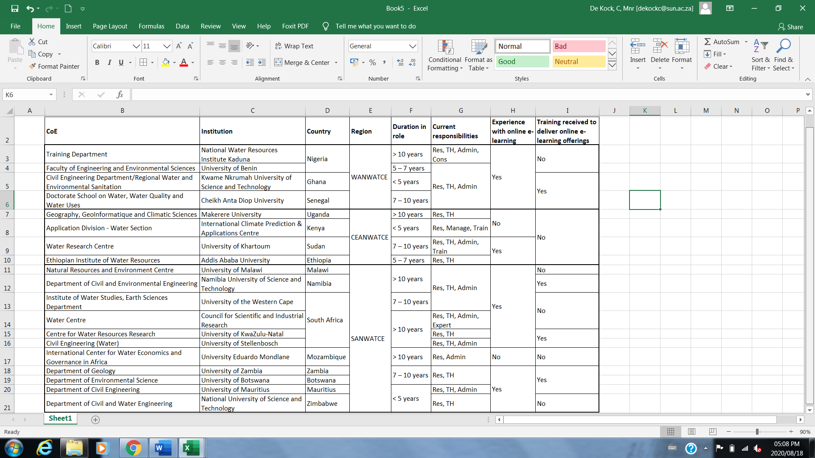

**Table 1: Comparison of background profiles between CoEs**

Res – Research; TH – Teaching; Train – Training, Manage – Management; Admin – Administration; Expert – Expert advisor; Cons – Consultancy

**SECTION 2: INSTITUTIONAL ONLINE E-LEARNING EXPERIENCE**

This section discusses the institutional online e-learning experience of the three regions, but also between the individual partners. The section comprises of the following indicators: the extent to which CoEs’ faculties/departments have incorporated ICT into academic offerings (Figure 3); when online e-learning offerings were introduced (Figure 4); preferred teaching model (Figure 5); whether faculty/department has provided any training related to online e-learning (Figure 6); collaboration with other Higher Education Institutions (HEI); and willingness to collaborate with other CoEs. All six indicators should also be considered in combination with Table 2 which illustrates a comparison between CoEs. Unlike the first four indicators, the last two indicators are not also represented by figures, but only the number of responses and Table 2.

Figure 3 below refers to the extent to which CoEs’ faculties/departments have **incorporated ICT aspects into their academic offerings**, which gives a broad indication of their move to a more online e-learning approach. At an individual CoE level, Table 2 shows that Stellenbosch University’s Engineering Faculty and the Department of Civil Engineering at the University of Mauritius, both in SANWATCE have fully integration of ICT with academic offerings.

Figure 4 illustrates **when online e-learning offerings were introduced**. From the results, three timeframes were identified namely 2005-2010, 2015-2019 and since March 2020 (in response to Covid-19).

Figure 3: Extent to which faculty has integrated Figure 4: Time when online e-learning offerings

ICT with academic offerings were established

Figure 5 looks at the regions’ **preferred teaching model**, face-to-face, blended or completely online. These results represent the feedback received from CoE respondents and therefore do not represent the entire department/faculty or institution. Table 2 shows that IWEGA in Mozambique, ICPAC in Kenya, The Water Research Centre at the University of Khartoum in Sudan, CSIR and the Centre for Water Resources Research – University of Kwa-Zulu Natal (UKZN) in South Africa, prefer face-to-face. IWEGA prefers face-to-face due to their non-experience with online e-learning (Table 1). The two latter institutions indicated that student interaction is important, body language can be determined and that a blended model would not sufficiently support some students who suffer from poor internet connectivity, power outages and hardware limitations. ICPAC stated that internet connectivity and costs have prevented them to move to a more blended model, while The University of Khartoum referred to the importance of practical work in the engineering field. The Natural Resources and Environment Centre at the University of Malawi is the only partner who prefers a fully online model, while all others partners prefer blended. Even though Makerere University indicated no experience with online e-learning (Table 1), they would still prefer a blended model.

Figure 6 with Table 2 show whether, and to what extent, the **faculty/department has provided any training** related to online e-learning. It should be noted that it was possible for people to have received training, while the faculty/department might have no integration of ICT with its academic offerings (Figure 3). Faculties/departments at SANWATCE partners have provided more online training compared to WANWATCE partners, while CEANWATCE indicated no training. The only partner in WANWATCE who indicated online and e-learning training was KNUST. The nature of KNUST ???training included preparation and uploading of materials, discussion platforms (lectures and tutorials) and assessments; economics of online learning; grading of submissions; student communication; Website editing.

Figure 5: Preferred teaching model Figure 6: Training provided by department/faculty

In terms of **collaboration** **with other HEIs** and/or TVET (Technical and Vocational Education and Training (Table 2) on online e-learning teaching, all CEANWATCE partners indicated that they do not engage in these types of collaboration, 9 out of 11 SANWATCE partners indicated that they do collaborate in online and e-learning trainings, whereas 2/4 WANWATCE partners are engaged with other institutions. The Faculty of Engineering and Environmental Sciences at the University of Benin City in Nigeria collaborates with other centres within the university namely the Centre of Excellence in Reproductive Health (World Bank assisted) and the Centre for Entrepreneurial Studies. The Doctorate School on Water, Water Quality and Water Uses at Cheikh Anta Diop University in Senegal collaborates with the Virtual University of Senegal and the Dakar regional office of *Agence Universitaire de la Francophonie* (AUF). The CSIR in South Africa collaborates with the University of Free State, also in South Africa and United Nations University in Japan. Lastly, the University of Mauritius collaborates with the Commonwealth of Learning.

Feedback showed that in terms of **willingness to collaborate** with other CoEs in online e-learning training, only 1/21 institutions (Ethiopian Institute of Water Resources at Addis Ababa University - CEANWATCE) indicated non-willingness to collaborate in online e-learning training. Reasoning for this is that training courses identified during the development of the Human Capacity Development (HCD) framework are different for every CoE. The respondent also indicated that its Institute also has two professional courses remaining which were going to be delivered in a blended manner.

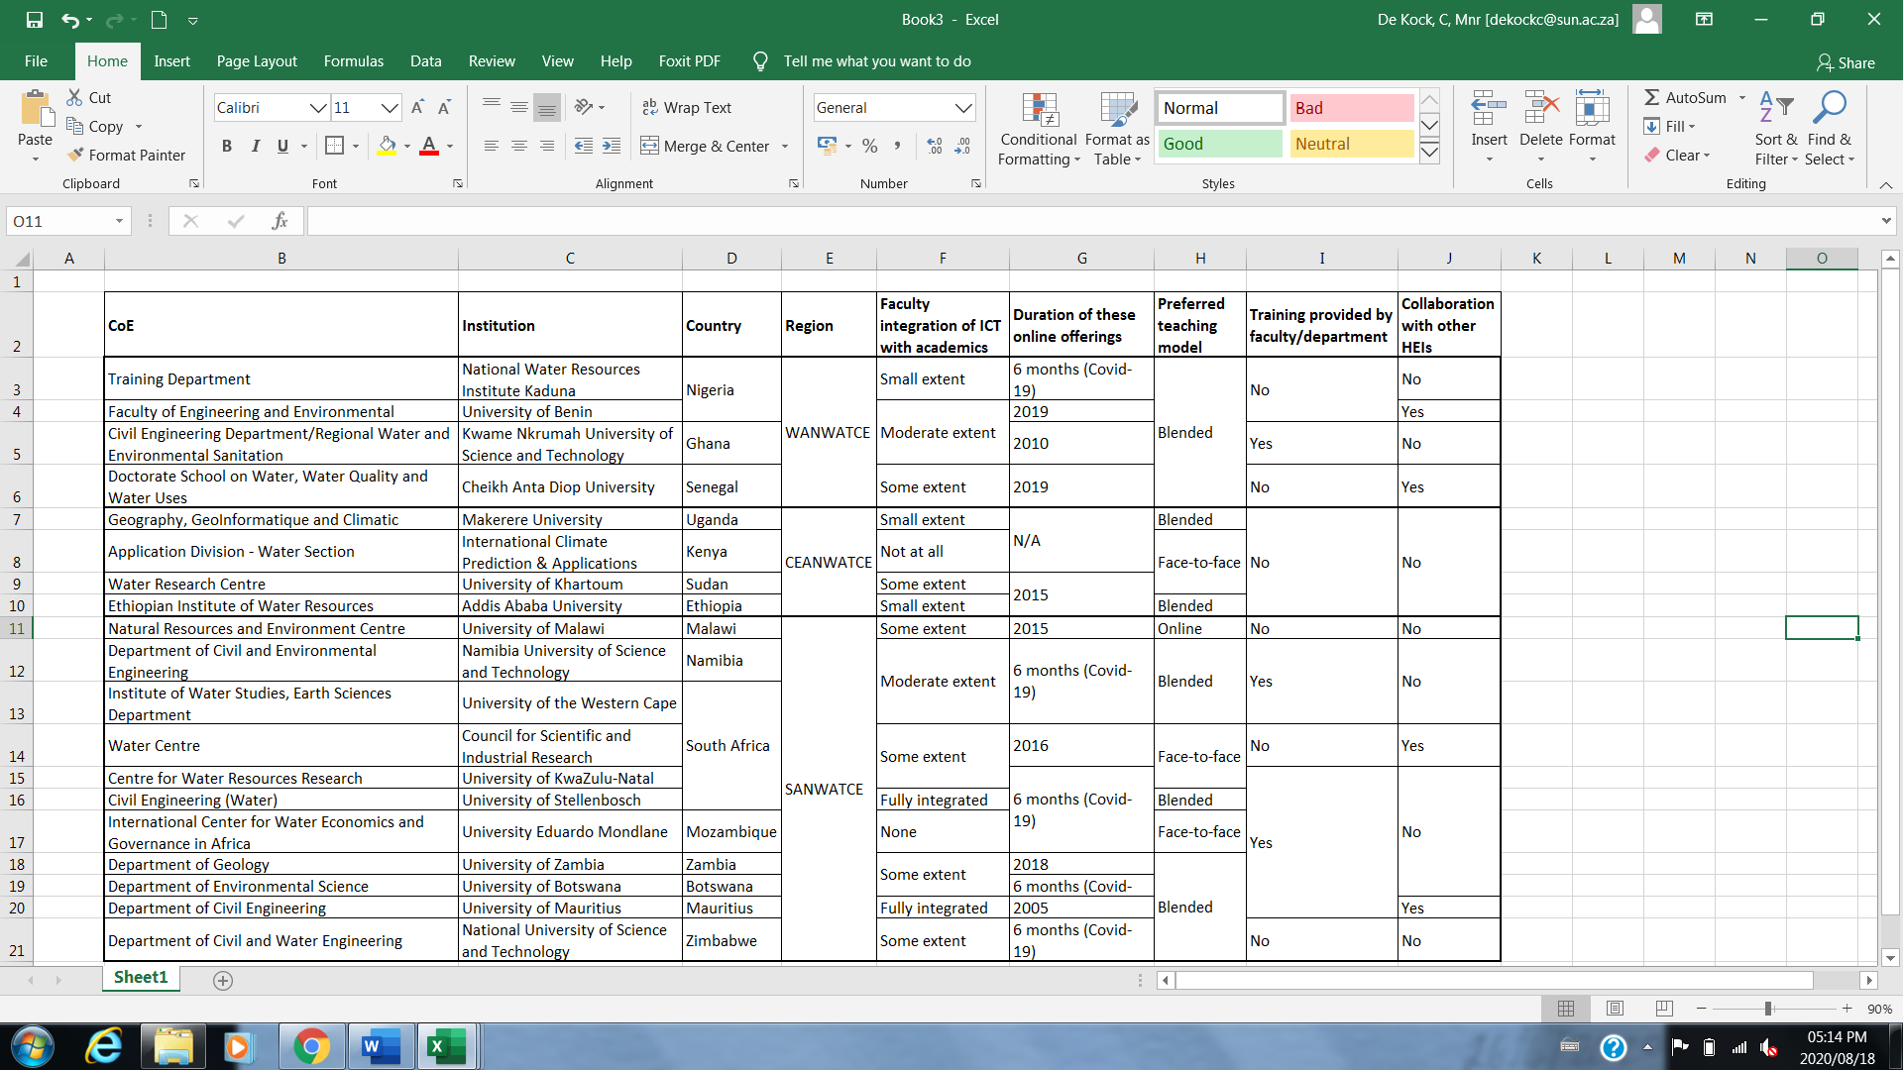

**Table 2 Comparison of Institutional Online E-Learning Experience among CoEs**

**SECTION 3: STAFF ONLINE E-LEARNING EXPERIENCE**

Section three illustrates the staff experience working with online e-learning of the three regions, and between the individual partners. The following indicators were included: whether online e-learning training had been delivered (Figure 7); if online e-learning was introduced in response to Covid-19 (Figure 8); access to adequate hardware and software; internet challenges in current work place (Figure 9); learning platforms currently in use (Figure 10); current work place (home or office); whether online e-learning can be delivered from current work place; and if they have access to access to course materials for such delivery.

These indicators should also be considered in combination with Table 3 which illustrates a comparison of staff online e-learning experiences among CoEs. Unlike the first four indicators, the last two indicators are not also represented by figures, but only the number of responses and Table 2. The first indicator, if online e-learning offerings had been delivered, informed the remaining indicators. I.e. those institutions who have not delivered, have N/A for the remaining indicators.

Figure 7 illustrates whether online e-learning has been delivered in the past. It shows that the majority of SANWATCE partners **have delivered online e-learning training**, 2/4 WANWATCE partners and 1 out of 4 CEANWATCE partners have delivered. In the former, IWEGA is the only partner who has not delivered such training. In CEANWATCE, the Ethiopian Institute of Water Resources in Ethiopia is the only partner who had delivered and in WANWATCE, both Nigerian partners have not delivered such training.

The next indicator looked at **whether online e-learning had been introduced in response to the Covid-19** pandemic (Figure 8). This figure shows that overall, 50% had introduced online e-learning in response to the pandemic. Table 3 shows that the one response from CEANWATCE was Ethiopian Institute of Water Resources in Ethiopia who also indicated the same. In the results for the previous indicator, those who had not delivered online e-learning training, were N/A for this indicator.

Figure 7: Delivery of online e-learning Figure 8: Online teaching in response to Covid-19

In terms of **access to sufficient hardware and software** resources to engage in online e-learning delivery of ACEWATER II pilot courses, 5/10 SANWATCE partners, the only WANWATCE partner and both CEANWATCE partners indicated insufficient access. Figure 9, Table 3 and additional qualitative information show the **needs** related to hardware and software. In WANWATCE, both KNUST in Ghana and Cheikh Anta Diop University in Senegal requires better internet connectivity and more affordable data. The latter also requires servers, software and a high-resolution camera. The prevailing needs in the other two regions are also the same. Additionally, the Ethiopian Institute of Water Resources in Ethiopia requires laptops for trainees and a subscription to online teaching platform(s) and learning tools. In SANWATCE, the University of Malawi needs smart online teaching boards, Liquid Crystal Display (LCDs) and related software. Stellenbosch University struggles with power outages due to load shedding and therefore requires Uninterruptible Power Supply (UPS). As previously, the same applied for those partners who were N/A. The Department of Civil and Environmental Engineering at Namibia University of Science and Technology; and the Centre for Water Resources Research at the University of Kwazulu-Natal are the only partners who indicated no internet challenges.

Figure 9: Internet challenges in current work environment Figure: 10: Learning platforms currently in use

Figure 10 and Table 3 illustrate the **learning platforms currently in use**. Here, one again, multiple responses were possible. This Figure shows that those indicated are fairly evenly spread in terms of usage, except for CEANWATCE who has no MS Teams usage. The University of Malawi indicated that Skype and Gotomeeting platforms are used, while the CSIR uses Rainbow.

For SANWATCE, 4/10 partners staff still **work from home** due to the Covid-19 lockdown regulations instated on 26 March 2020, whereas for WANWATCE, 1/2 partners’ staff still work from home. In CEANWATCE, Addis Ababa University-Ethiopian Institute of Water Resources was the only relevant respondent. This partners still has access to its offices.

All institutions have indicated that they are **in a position** **to deliver online e-learning** from their current working place, while they also have **access to course materials** for teaching preparation and delivery during Covid-19 restrictions. While many partners indicated insufficient hardware and software (and support – Section 4) to deliver online e-learning courses, they are still able to deliver. In other words, access to additional hardware and software would able them to deliver courses more adequately.

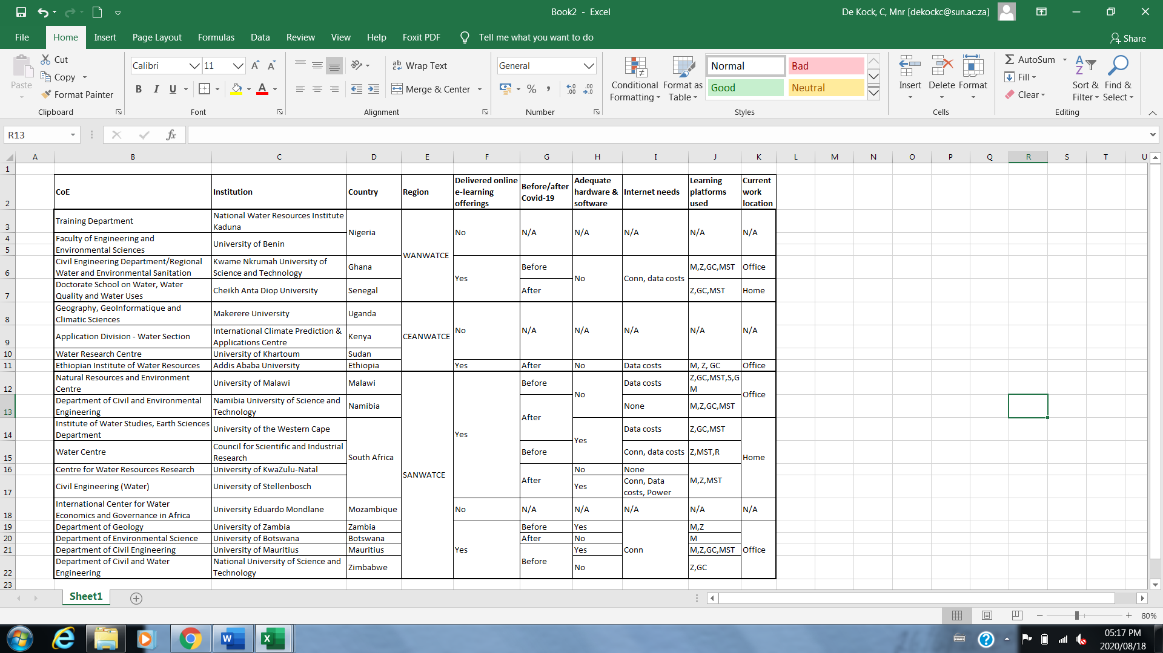

**Table 3: Comparison of Staff Online E-Learning Experience among CoEs**

Conn – Connectivity; M – Moodle; Z – Zoom; GC – Google Classroom; MST – Microsoft Teams; R – Rainbow; S – Skype; GM – Gotomeeting

**SECTION 4: INSTITUTIONAL LEVEL TECHNICAL AND LEARNING SUPPORT**

Section four discusses the institutional level technical and learning support within the CoEs in the three regions, and between the individual partners. The following indicators were included: access to sufficient ICT hardware and software support (Table 4); access to sufficient teaching and learning and/or communications support; if yes, access to type of support (Figure 11) which should also be considered in combination with the Table mentioned, which illustrates a comparison among CoEs. The first two indicators are not represented by a figure, but only the number of responses and Table 4.

Overall, 53% have access to **sufficient ICT hardware and software support** in current working situation for online e-learning – SANWATCE (7/11), WANWATCE (2/4) and CEANWATCE (1/4).

In terms of the second indicator, **access to teaching and learning and/or communication support,** 100% of WANWATCE has sufficient access (Table 4). The National University of Science and Technology in Zimbabwe is the only institution with insufficient support, while in CEANWATCE, the Ethiopian Institute of Water Resources in Ethiopia is the only partner with sufficient support.

Where partners have indicated they have sufficient support, elaboration about the type of support was requested and is illustrated in Figure 11.

Figure 11: Access to type of ICT hardware and software support

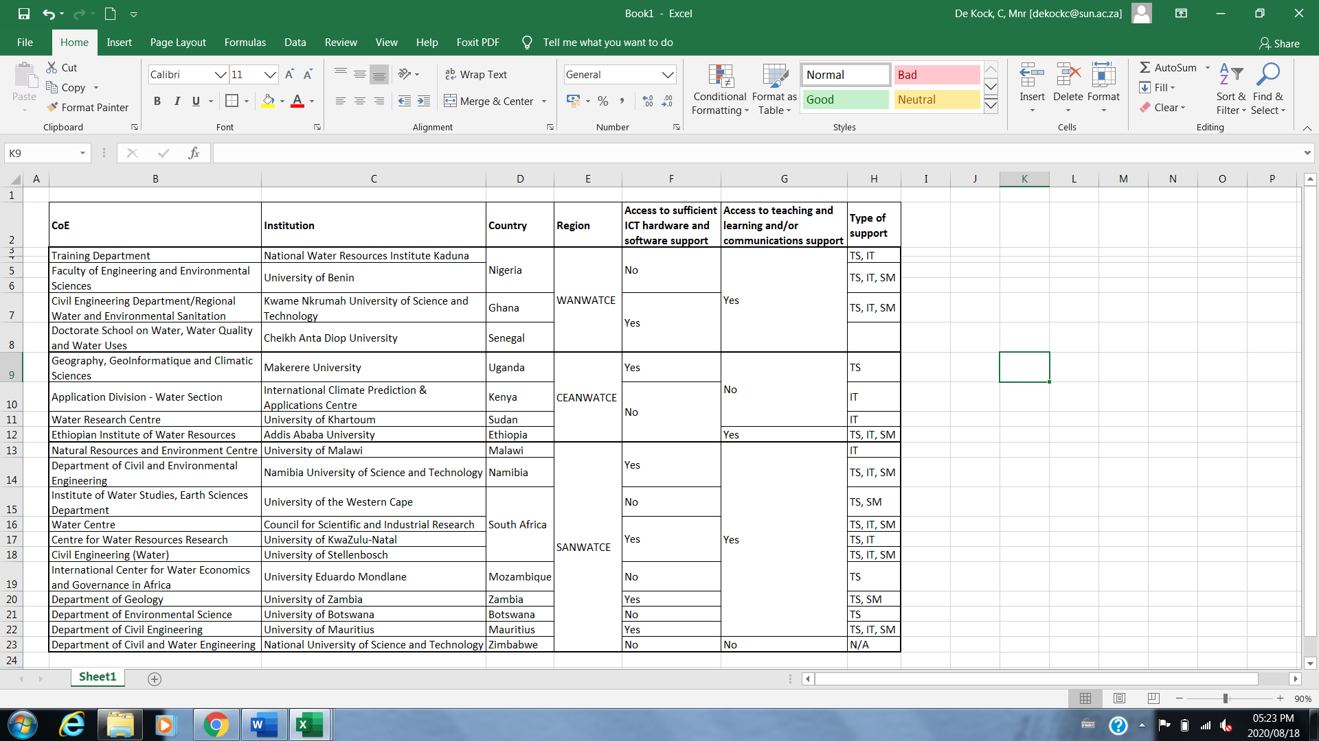

**Table 4: Comparison of Institutional Level Technical & Learning Support among CoEs**

TS – Training sessions for online e-learning delivery; IT – Backup IT support; SM – Delivery support materials (e.g. manuals, materials, Powerpoint, videos)

**SECTION 5: STUDENT (CAPACITY) ONLINE E-LEARNING EXPERIENCE**

The last section investigates from the CoE’s experience and perspective students’ capacity to engage with online e-learning, with the following indicators: students' ability to use online e-learning systems and platforms (Figure 12); student challenges (Figure 13); students’ ability to work remotely (Figure 14); and finally, if online e-learning is considered an effective mode of learning (no figure, only number of responses). The first indicator illustrates the broad student experiences with online e-learning platforms and systems. This relates to the next indicator of student challenges (Figure 13) and finally Figure 14, which again illustrates a broad ability to work remotely. These indicators should also be considered in combination with Table 5, which illustrates a comparison among CoEs.

Figure 12: Students’ ability to use online e-learning platforms Figure 13: Student challenges related to online learning

Figure 12 and Table 5 show that for CEANWATCE and WANWATCE, 2/4 partners each indicated that their **students are able to use online e-learning systems and platforms**, whereas in SANWATCE, the number of students able to access these platforms is higher.

Figure 13 indicates that **student challenges**, as identified by the CoE staff, are evenly spread between internet connectivity, data charges and hardware. In SANWATCE, the University of Malawi and University of Kwazulu-Natal indicated that power outages are also problematic. National Water Resources Institute Kaduna Nigeria in Nigeria indicated that some of their students struggle due to a lack of sufficient ICT knowledge.

The next indicator relate to the previous two and shows **students’ ability to work remotely** (Figure 14). Once again, results seem fairly evenly spread, between a small extent, some extent and moderate extent. According to Table 5, in WANWATCE the University of Benin in Nigeria and Kwame Nkrumah University of Science and Technology in Ghana regard their students as moderately able. In CEANWATCE, ICPAC and Water Research Centre University of Khartoum in Sudan indicated a low ability, while in SANWATCE most partners indicated a higher ability, three partners with a low ability and three, to some extent.

Figure 14: Students’ ability to work remotely

CoEs were consequently asked whether **online e-learning is an effective mode of learning**. 100 % of respondents felt that it is indeed effective. While a few CoEs indicated that they have either no experience with, nor ever delivered online e-learning (Figure 7), or received training (Figure 6), their opinions relate to current Covid-19 lockdown regulations, the ability of online models to reach more participants (in terms of geography and time restrictions), lower implementation costs.

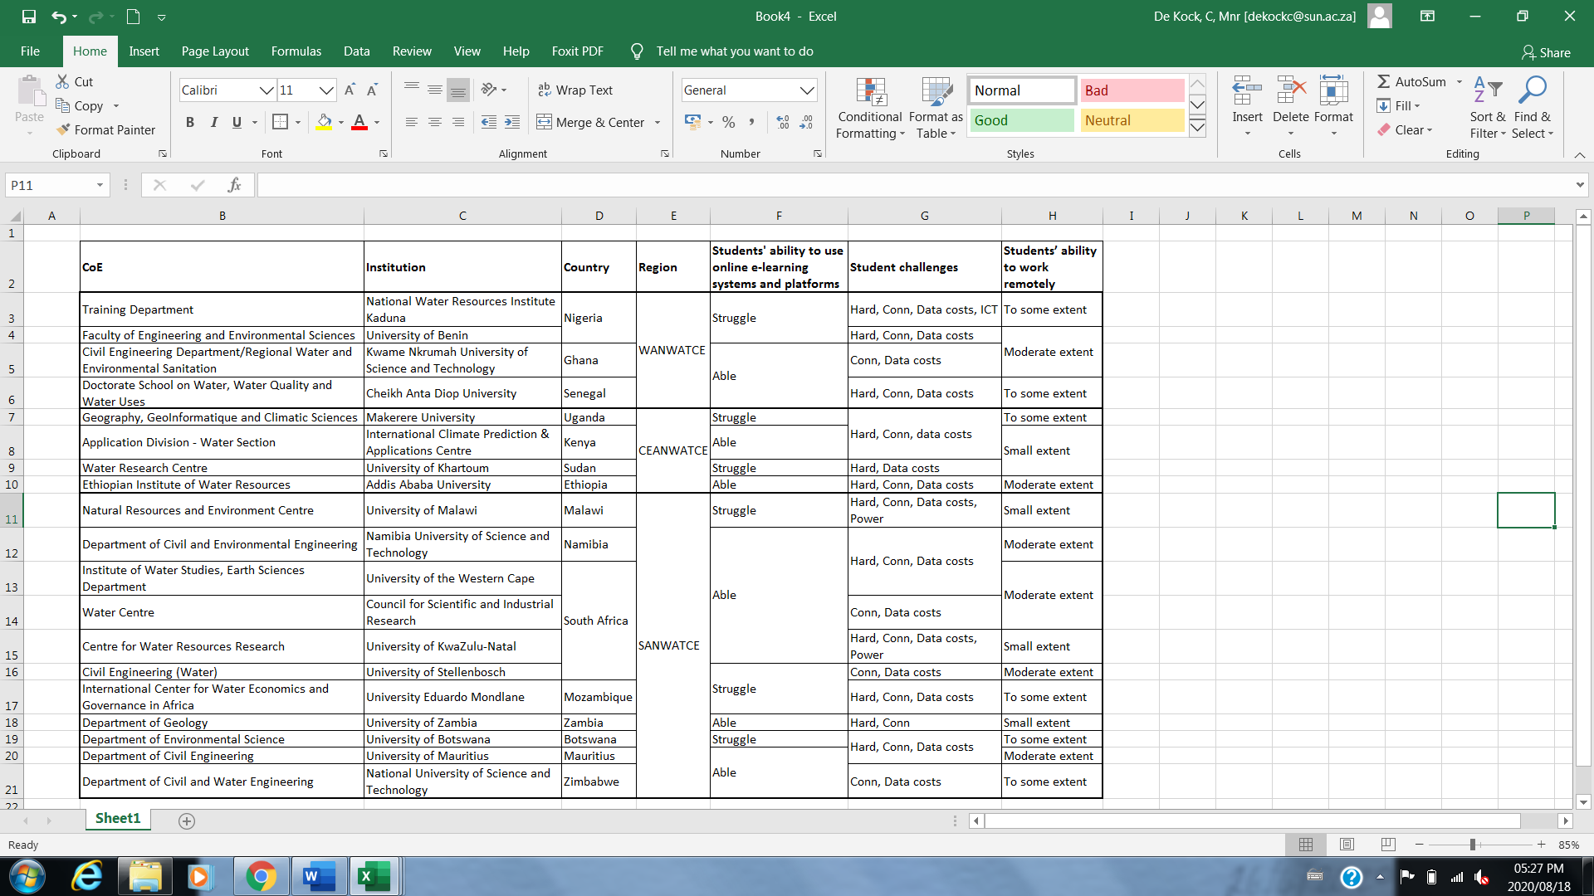

**Table 5: Comparison of Student (capacity) online e-learning experience between CoEs**

Hard – Hardware; Conn – Connectivity; ICT – Information and Communications Technology Knowledge; Enviro – Interruptive environment; Power- Intermittent power supply